Description | QTY | Price | Total
Junior Starter Set (1x junior backpack, 1x homework folio,  1 x excursion bag, 1x fridge pocket) |  | $55.00
Senior Starter Set (1x senior backpack, 1x homework folio,  1 x excursion bag, 1x fridge pocket) |  | $60.00
Junior backpack |  | $35.00
Senior backpack |  | $40.00
Homework/Library folio |  | $10.00
Excursion Bag |  | $10.00
Fridge Pocket |  | $3.00
Rain Poncho – Medium |  | $15.00
Rain Poncho – Large |  | $15.00
 | TOTAL |  | $
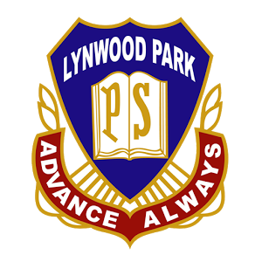
Student name: Class:
Parents name:
Contact number:

Sign Date
CASH ONLY payable at time of order (Due to the current COVID situation, money and orders need to be sent to the school office in an envelope and orders will be delivered to students’ class)

Purchase Order

Lynwood Park Public School P&C Association
ABN: 438 126 212 54 Ph: (02)9622 2659
87 Turner Street, BLACKTOWN NSW 2148
Child’s Name:
Childs Class/Year:
Your Name:

